RULES AND REGULATIONS GOVERNING THE USE AND REGISTRATION OF
COLOURED JACKET & HOODIE

- Coloured jackets/hoodies may be worn in any event controlled by the English Indoor Bowling Association Limited (EIBA Ltd) providing that EIBA Ltd has given prior consent and approval of the design of the item to be worn. Applications for the design of a jacket/hoodie, including registration fee, shall be made to EIBA Ltd on the appropriate form. Once the design has been approved a Registration Certificate will be issued.

- Following this procedure, a jacket/hoodie in the registered colours may be worn by an individual, team or side in any event under the direct control of EIBA Ltd provided that the Club at which the tie is to be played permits the wearing of coloured outerwear. In a team or sides event, if jackets/hoodies are to be worn, the same registered item must be worn by ALL members of the team or side. In mixed events where men and women have different registered coloured jackets/hoodies, all men should wear the same design and all women should wear the same design.

- The wearing of a coloured jacket/hoodie, which has not been approved may result in elimination from further participation in that event. In very exceptional circumstances players arriving at Championship Finals in non-registered outerwear will be given an application form to immediately temporarily register their items and will be allowed to compete and play in the event providing the appropriate registration fee is paid.

- Design

- Jacket/hoodies shall have long sleeves and may have a collar or hood. The design may include as many colours as required and a maximum of 4 commercial logos including a manufacturer’s logo may be placed on the design.

- Jacket/Hoodie Front – can include
1 commercial logo not exceeding 12.5cm x 12.5cm
1 club/county badge not exceeding 12.5cm x 12.5cm

- Jacket/Hoodie Back – can include
A Club/County name or Sponsor not exceeding 25cm long x 7cm high.

- Jacket/Hoodie Sleeve – can include
A Sponsors logo on the right and/or left sleeve not exceeding 12.5cm x 10cm

- Personal Sponsor - A Personal Sponsors logo to be placed on either sleeve (size as above) may be submitted by a player to his Club or County for approval by EIBA Ltd. When approved this jacket/hoodie may only be used by the player in Singles Competitions unless all his team members have the same Personal Sponsor and Registered Jacket/Hoodie design. A Personal Sponsor’s logo can be attached to a club/county outerwear where space permits i.e. within the allocated specification of a maximum of 4 commercial logos including a shirt logo.

- Once a design has been approved and registered, no changes will be permitted without further approval from EIBA Ltd. A Club or County can register many alternative designs, but they must be on separate forms with sufficient payment.

There is a £10 registration fee per design, payment options are detailed on the form on the next page.

From: .......................................... (Secretary) of ..................................................Indoor Bowls Club/County I.B.A.*

Please email electronic version of the imagery to enquiries@eiba.co.uk
Men’s / Women’s (*delete as appropriate)

Email address where the certificate to be sent ……………………………………………………………………………….

I wish to apply for approval of the design of the jacket/hoodie to be worn by players of above Club/County Association* in games under the control of the English Indoor Bowling Association Ltd.

The jacket/hoodie base colour will be: ....................................................................................

The secondary colours will be: ....................................................................................

The secondary colours will be used for: ....................................................................................
(e.g. Cuffs, Collar, Sleeves etc.)

I enclose samples of the colour(s) that will be used for the jacket/hoodie and the sketch below shows how the jacket/hoodie will look. I also enclose copies of the Club/County* badge and the Sponsors advertising material at the size they are to be used. (* Delete as appropriate)

I understand that the jacket/hoodie may not be used in any event under the control of EIBA Ltd before confirmation of its approval by EIBA Ltd. Once the design has been registered and a certificate issued no changes will be made to the design without written permission from EIBA Ltd.

PAYMENT OPTIONS FOR THE £10 REGISTRATION FEE
□ Bank Transfer: Sort Code: 20-99-40 Account No: 93531465 Account Name: EIBA Ltd Ref: jacket registration
□ Cheque: Please ensure cheques are payable to the English Indoor Bowling Association Ltd
□ Credit/Debit Card: Please telephone HQ 01664 481900.

Signed: .............................................................. Date: ..........................................

Please indicate on the sketch where alternative colours will be used and enclose samples of the proposed colours for reference. Hoods or collars are acceptable, as are buttons or zips. Please indicate the proposed positioning of any logo, wording, or badge.

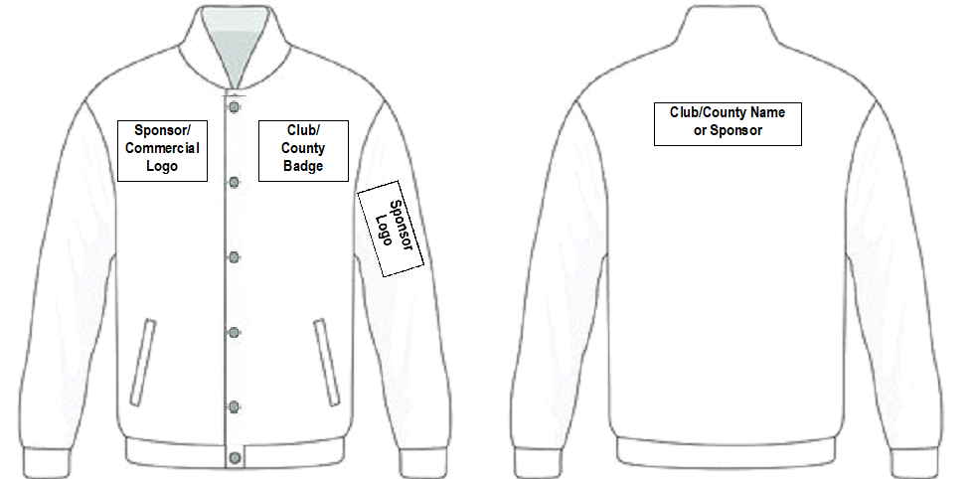
Front Back

Please email electronic version of the imagery to enquiries@eiba.co.uk
July 2024

